**Web Technology with**

**UI/UX**

**Task-2: Prepare a prototype design of a website in Figma which contains at least 8-10**

**screen or maximum as required. Upload screen design in assignment_1 folder.**

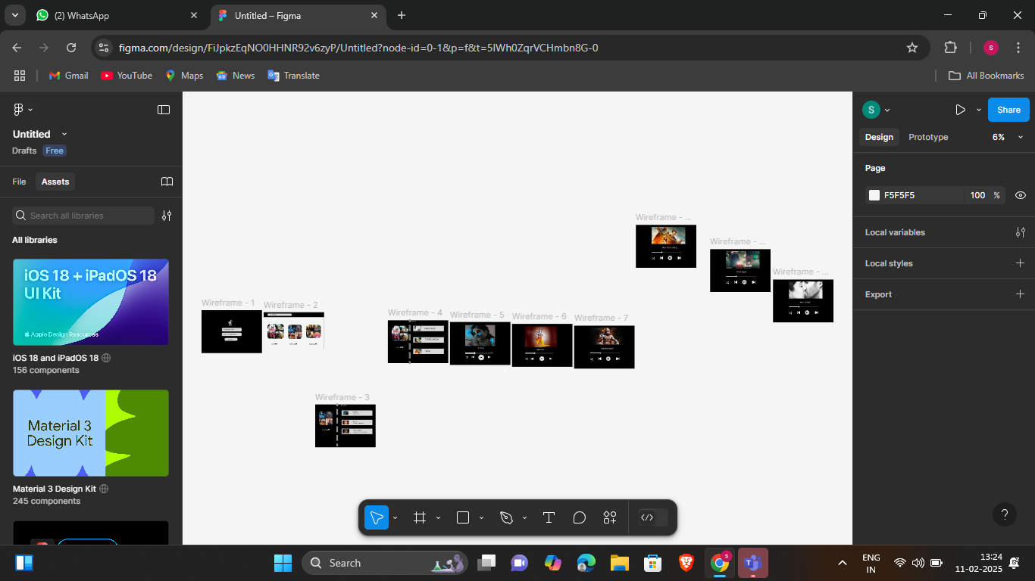

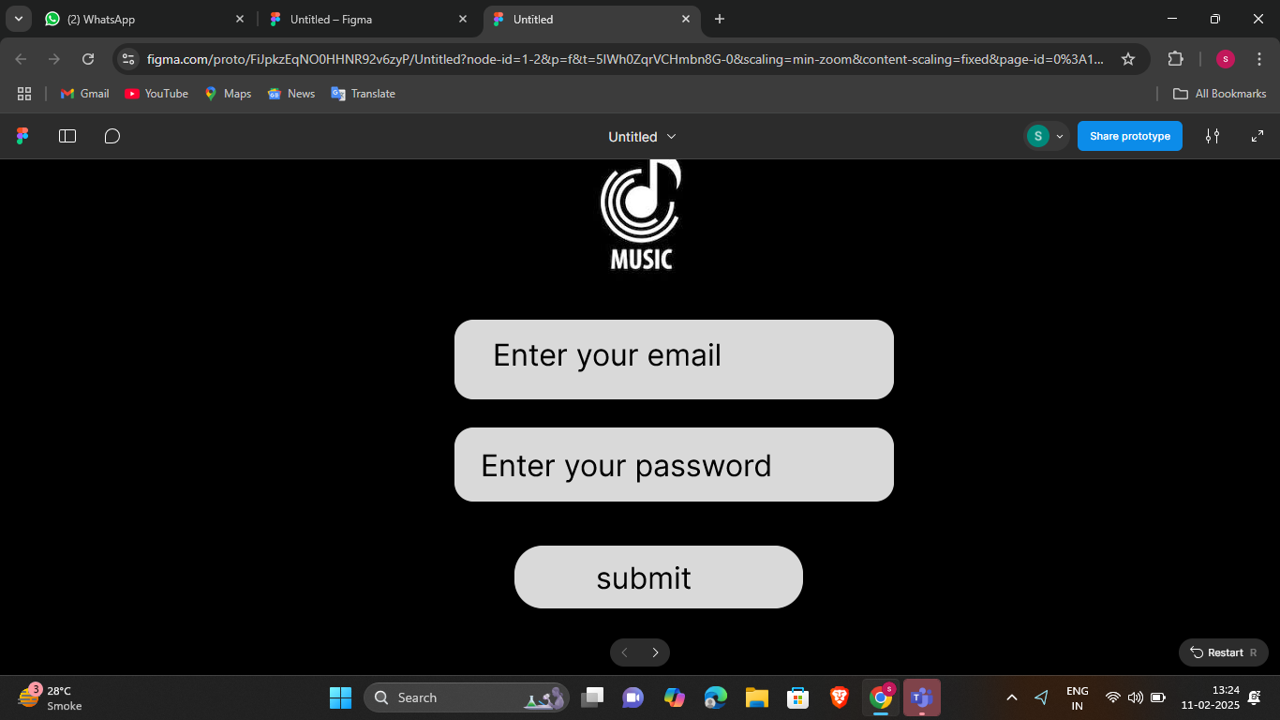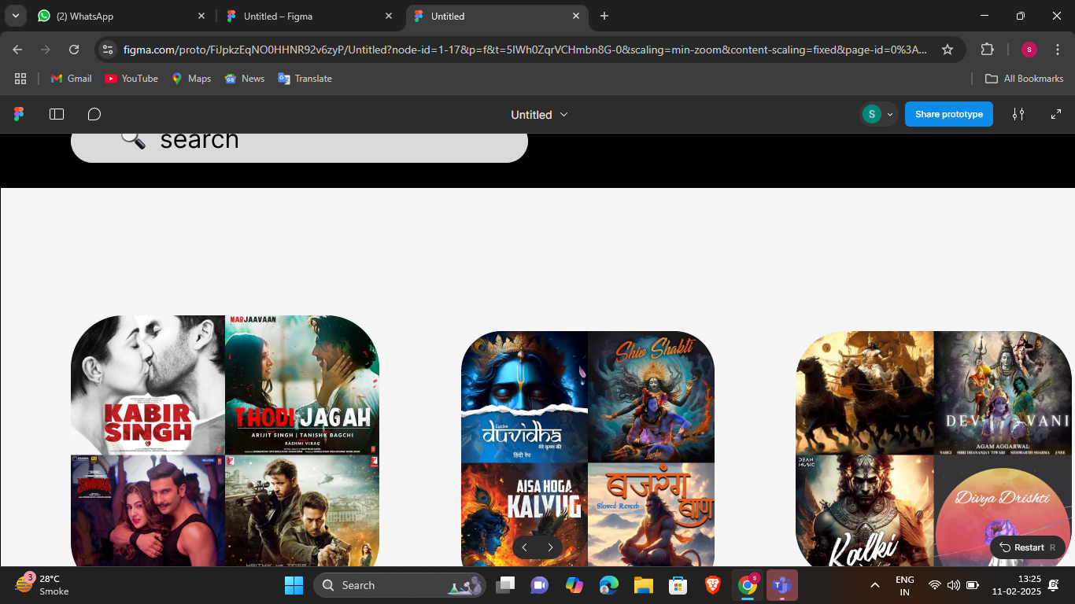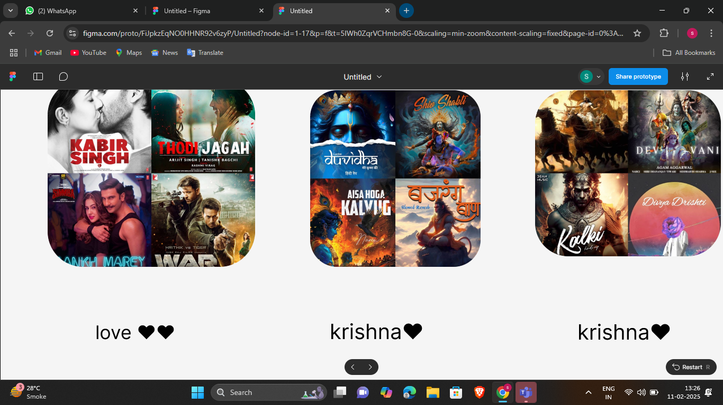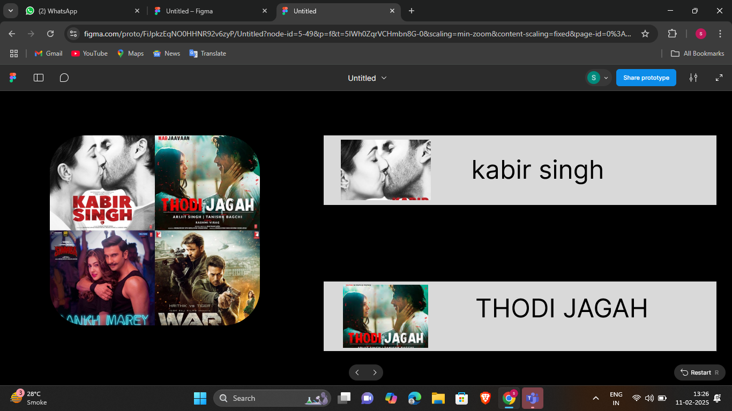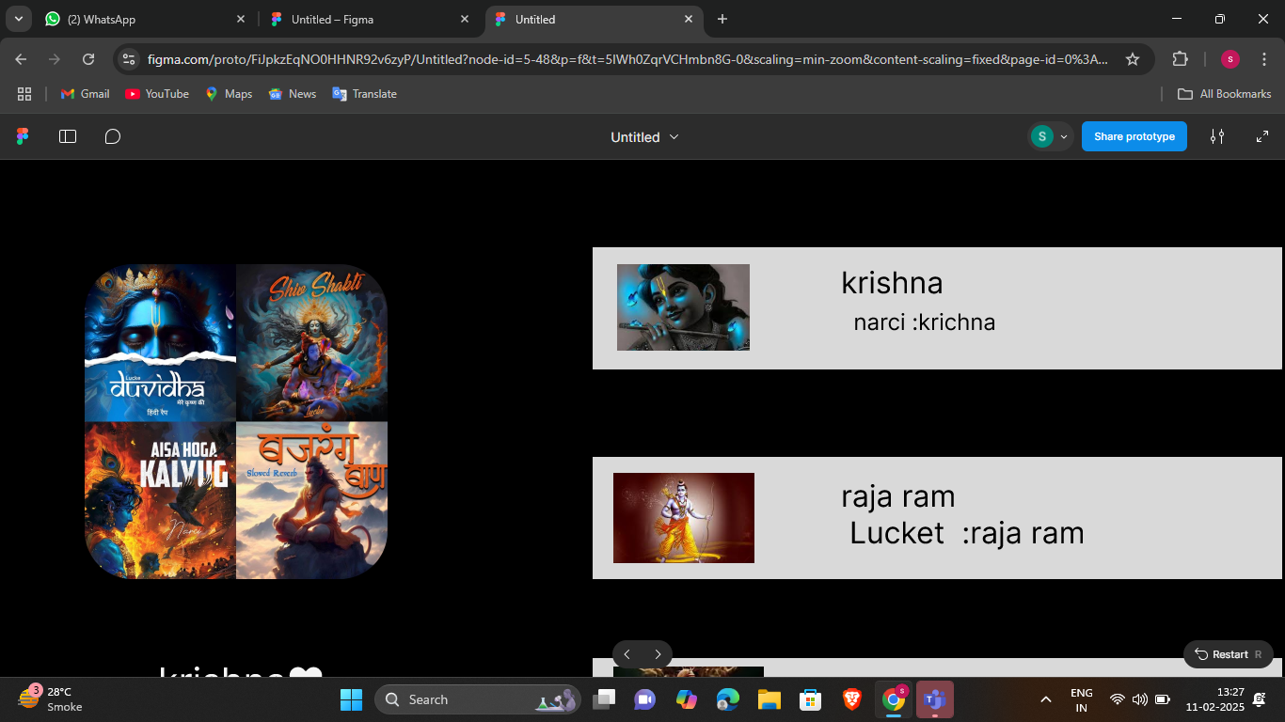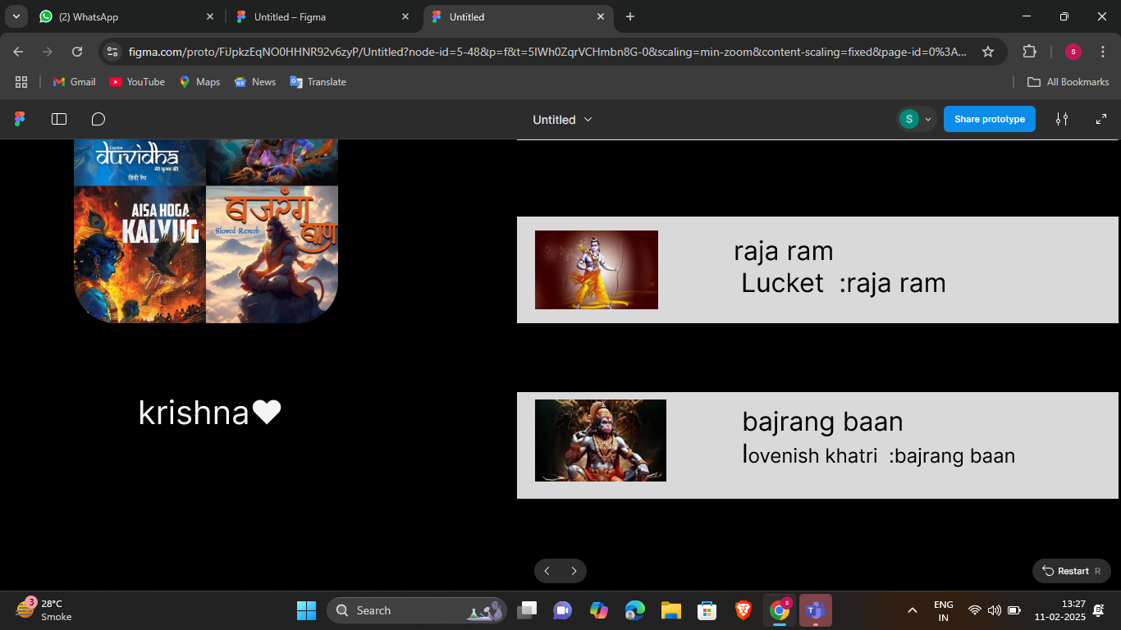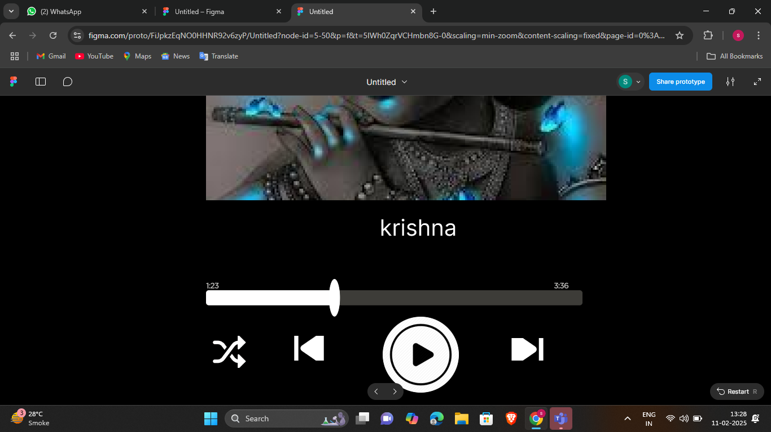

**Guided By -**

**Mr. JayKumar Gandharva**

**Prepared By -**

**Patoliya Sahil**

**2402030430088**

**4CE_C_047**